Welcome to Ciphr!
28 January 2026
Dear {Known As}
Welcome to Ciphr, we are delighted to welcome you to our team.
As an employee, we want you to be involved in maintaining the data we hold about you and give you access to information about your employment with us. We have an internal system called #NAMEOFSYSTEM# which allows you to carry out these tasks and much more.
This letter will give you information about the following:
- Getting set up on the Employee HR Self Service Portal
- How to navigate #NAMEOFSYSTEM# – watch useful video guide
- Company Induction process – you must complete this before arriving for your first day
- Our People
You should allow approximately one hour to get yourself set up and go through the induction and onboarding process. It’s important that you share your information with us prior to your start date so that your first week with us goes as smoothly as possible and we are able to pay you on time!
Your employee HR self-service portal – GETTING SET UP!
You can access this on any device connected to the internet via the designated URL. Please note it is your responsibility to ensure the security of the information you are viewing when accessing your personal data on your chosen device. Particular consideration should be given when accessing this in a public space where others may be able to see your information ‘over your shoulder’.

https://yourcompanyname.app.ciphr.com
Use the web link above to open #NAMEOFSYSTEM#’s login page.
**Tip – We recommend using a tablet or PC/laptop to complete the initial setting up of your account**
If using username/password:
You will need the following details, which are confidential, to get started.
- Your system email address: {Contact Email}
- Your password: Please use the ‘reset password’ link
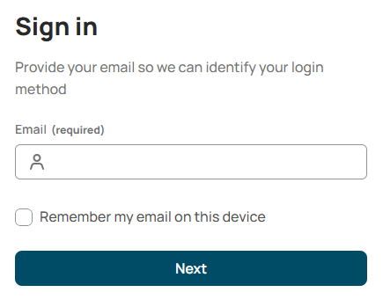
- Start by clicking on ‘Set/Reset password’
- Enter your system email as given above
- Fill in your details

This will send you a verification code to your system email address. This code is time sensitive and must be used straightaway. You may need to refresh your inbox or check your junk folder.
Having successfully input your verification code you will be required to set up a password.
That’s it, you’re all set up.
It’s important that you now complete the Company Induction and complete all the details requested of you via self-service.
If using single sign on:
- Simply enter your system email address: {Contact Email} and click Next
- The system will use your existing security profile to log you straight into the system

When you log in
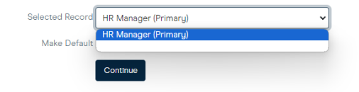
After you have entered your details, in most cases you will be taken straight into your account. However, if you have more than one job with us (a secondary role) you may encounter the screen asking you to select a record.
If so, and there is no job title shown in the selected record, do not change anything and just click continue.
Where there is a choice, you must always select the line that has (Primary) at the end to complete or update any information.
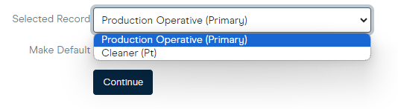
The other line will be your secondary role where you can view the job and job description. You WILL NOT be able to update personal details in this record.

Navigating the System
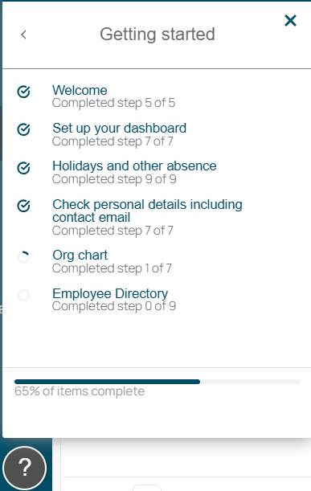
Once you are all set up you will be greeted by a welcome message and short guide to show you around the system.
Please take the time to follow the guides in the ? help menu at the bottom left of the menu bar. The Getting started module has recommended guides to get you up and running

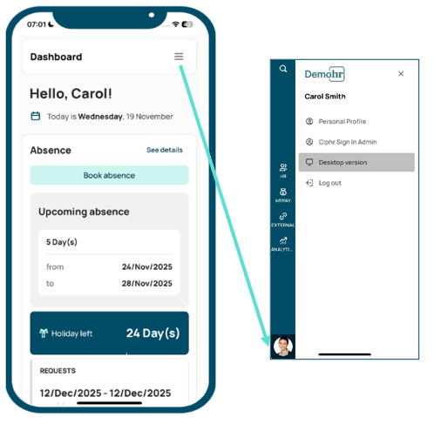
If you are using a smartphone and the screen looks like this, click on the burger menu top right, then your image/initials bottom left and select desktop version in order to complete the next steps:

Company Onboarding Induction
- Onboarding - Please go through all the content on each page
- Personal Details - Click on Personal > Personal Details and complete any fields where data is missing, particularly:
- NI Number
- Birth Date
- Bank Details
- Emergency and Other Contact Details – Click on Personal > Emergency and Other Contact Details and complete the information for your next of kin
- Additional Information – Click on Personal > Additional Information and complete the following forms:
- HMRC Starter Checklist
- Dietary and Allergens
- Salary Sacrifice Agreement
- Beneficiary Details
- Working Time Regulations Opt Out
- Photo – Click on Personal > Upload Photo and upload a photo of yourself for use across our systems. This should be a photograph of yourself (no pets or famous faces!) in simple, conservative clothing. Avoid other objects, people, pets, children and ‘busy’ backgrounds
- Book & View Time Off – If you have any pre-booked annual leave to take, click on Holidays & Absence > Book & View Time Off and click on Insert New Record to add a new holiday request. Please note that this should have been discussed at interview
- Compliance – Click on Employee Checks & Compliance > Safeguarding & Employee Checks and complete the following forms:
- Right to Work
- Reference Details
- Medical Information
- Documents – Click on Personal > Personal Documents and ‘Insert New Record’ to upload the following documents:
- Passport
- Driving Licence
- MOT certificate
- Maths and English GCSE certificates
- Skills and Qualifications – Click on Performance & Development > Skills & Qualifications and click Insert New Record to let us know your educational and professional skills and qualifications. Please also add any Health and Safety qualifications that are still in date
If you have any questions or problems completing any of the above, please don’t hesitate to contact us on hr@mycompany.com
We look forward to welcoming you onboard.
Kind regards
HR Team

