*Use this guide to inform your users about the upcoming changes to sign in. Edit as necessary to suit your organisation’s processes. Red text highlights particular text you may wish to edit/delete as applicable for your organisation.*

# [System name] sign-in user guidance for single sign-on users

As we use single sign-on (SSO) to sign-in to [system name], when you reach the sign in screen, enter your work email address and the system will identify your account and allow you to proceed.

1. 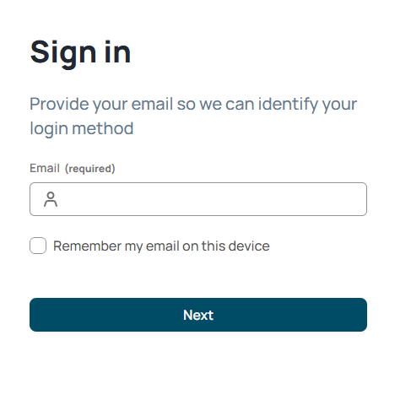If signing in on your own device, be sure to tick the **Remember my email on this device** which will save your email for a faster login next time.

|  |
| --- |
| **Note: Please don’t tick the box if using a shared device.** |

Click **Next.**

1. A screenshot of a login page

   AI-generated content may be incorrect.The first time you sign in you may need to authenticate your details.

Enter your email address again and click **Next**.

|  |
| --- |
| **Note:** If you are advised to pick an account, then check the account(s) listed and select Use another account if you need to change it to match your Sign in email account. |

1. 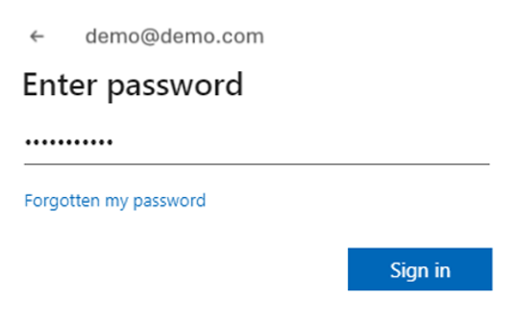Enter your password that you use to log in to your work account and click **Sign in** to access [System name].

You’re now all set and will only need to complete step 1 going forward.